**DEVOPS TASK- 2**

NAME : SURYA U S

ROLL NO : 22CSR214

**STEP 1 : INSTALLATION OF DOCKER.**

# CODE :

sudo apt install docker.io Docker version

sudo systemctl start docker sudo systemctl enable docker sudo systemctl status docker

# SCREENSHOT:

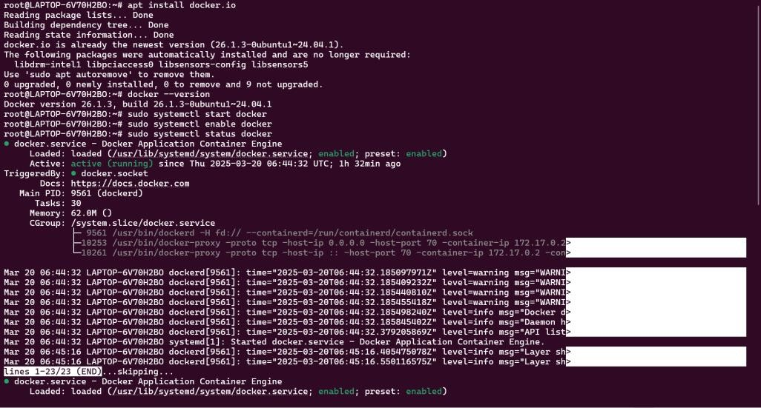

**STEP 2 : AFTER STEP 1, FORK A COPY OF A GITHUB REPO WHICH CONTAINS THE NECESSARY FILES WHICH WILL RESULT IN THE CLONE OF THAT REPO IN OUR OWN REPOSITORY**.

# SCREENSHOT:

# 

# 

**STEP 3 : AFTER STEP 2 ,THEN CHANGE THE TOKEN AND REPO NAME OF THE DOCKER HUB IN THE DEPLOY.SH FILE WHICH IS IN OUR REPOSITORY.**

**SCREENSHOT:**

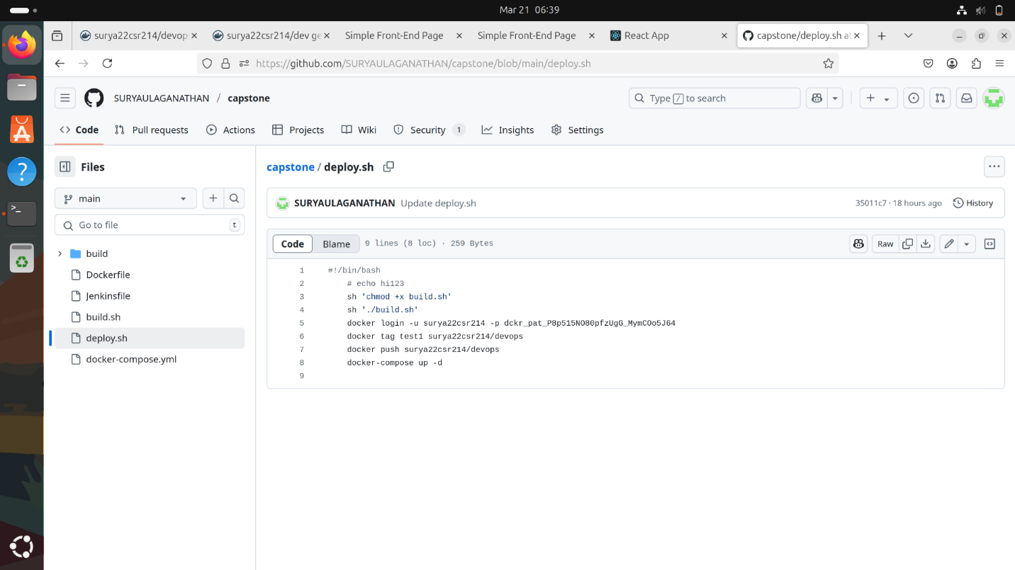

**STEP 4 : AFTER STEP 3, COPY THE GITHUB LINK OF THE REPOSITORY AND GO TO JENKINS.**

**SCREENSHOT:**

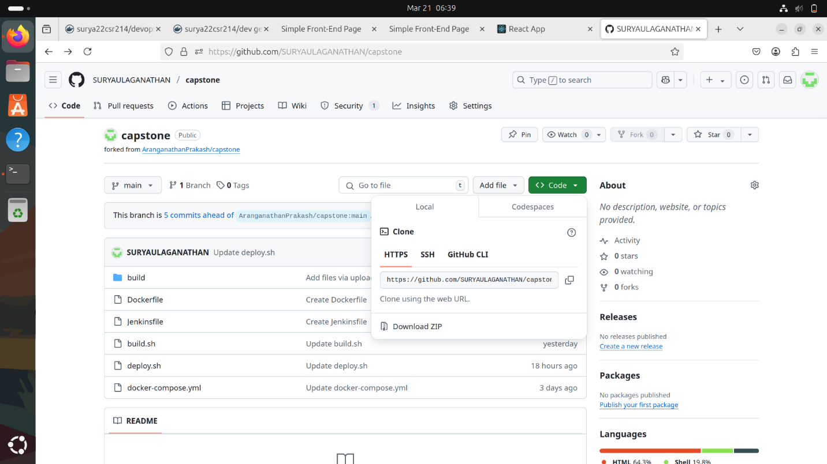

**STEP 5 : AFTER STEP 4, IN JENKINS, CREATE A NEW ITEM (JOB) WITH A TYPE PIPELINE AND ADD THE COPIED GITHUB URL TO IT WITH THE CORRECT BRANCH AND JENKINSFILE.**

**SCREENSHOT:**

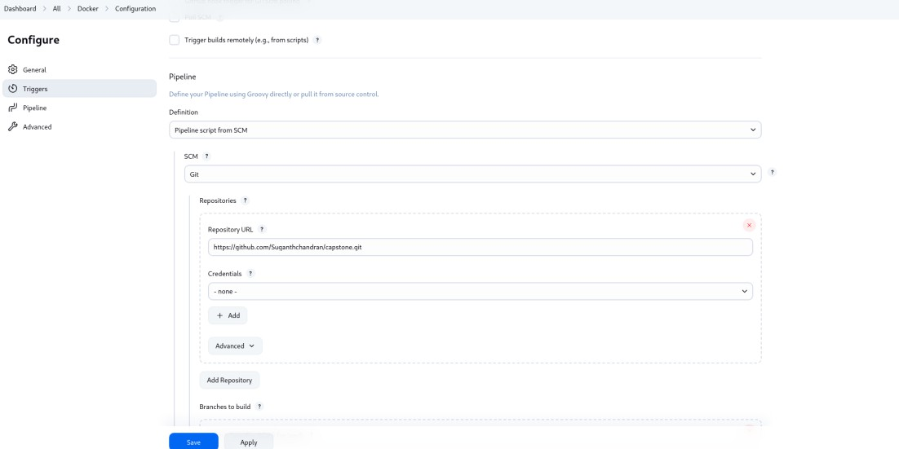

**STEP 6 : AFTER STEP 5, AFTER CREATING THE JOB, BUILD IT AND IT WILL GIVE THE CONSOLE OUTPUT AND THE DOCKER IMAGE WILL BE CREATED.**

**SCREENSHOT:**

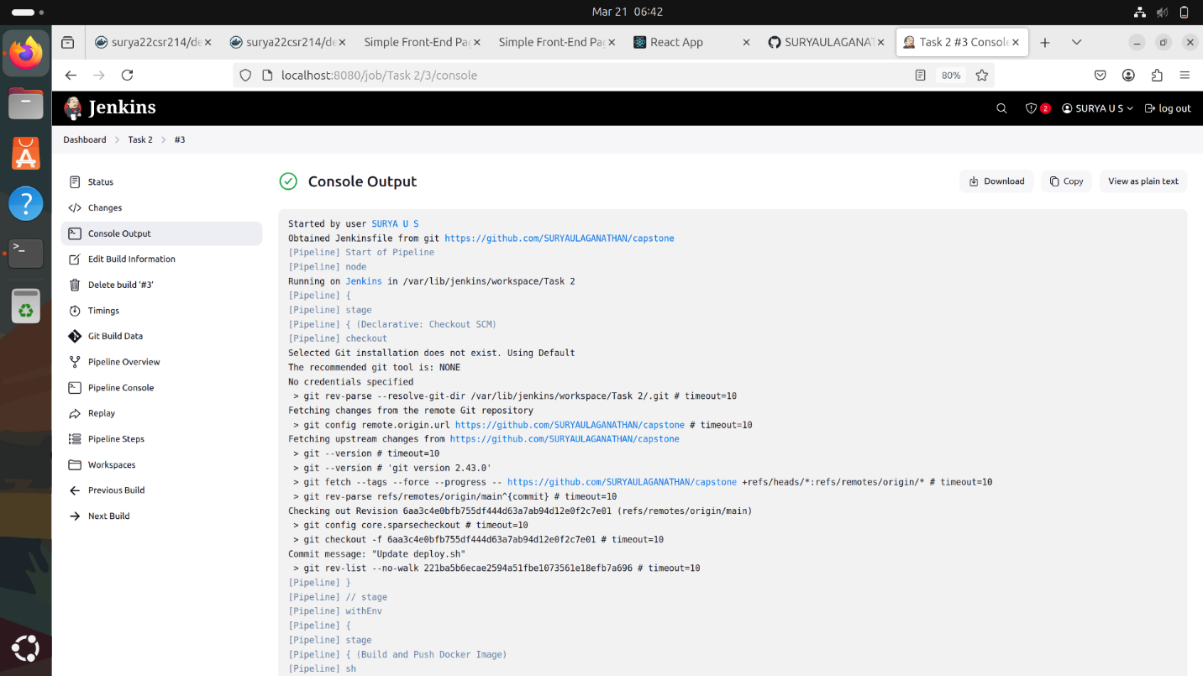

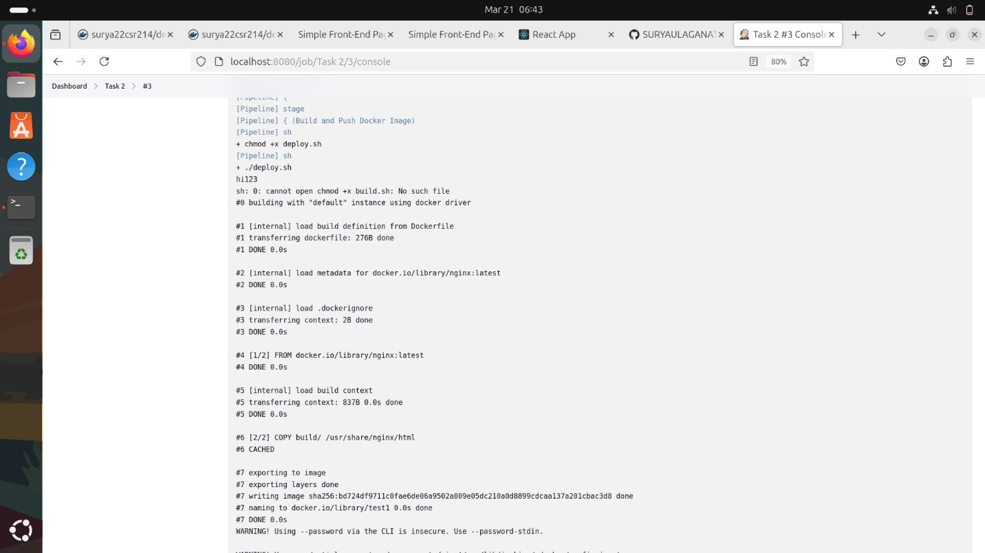

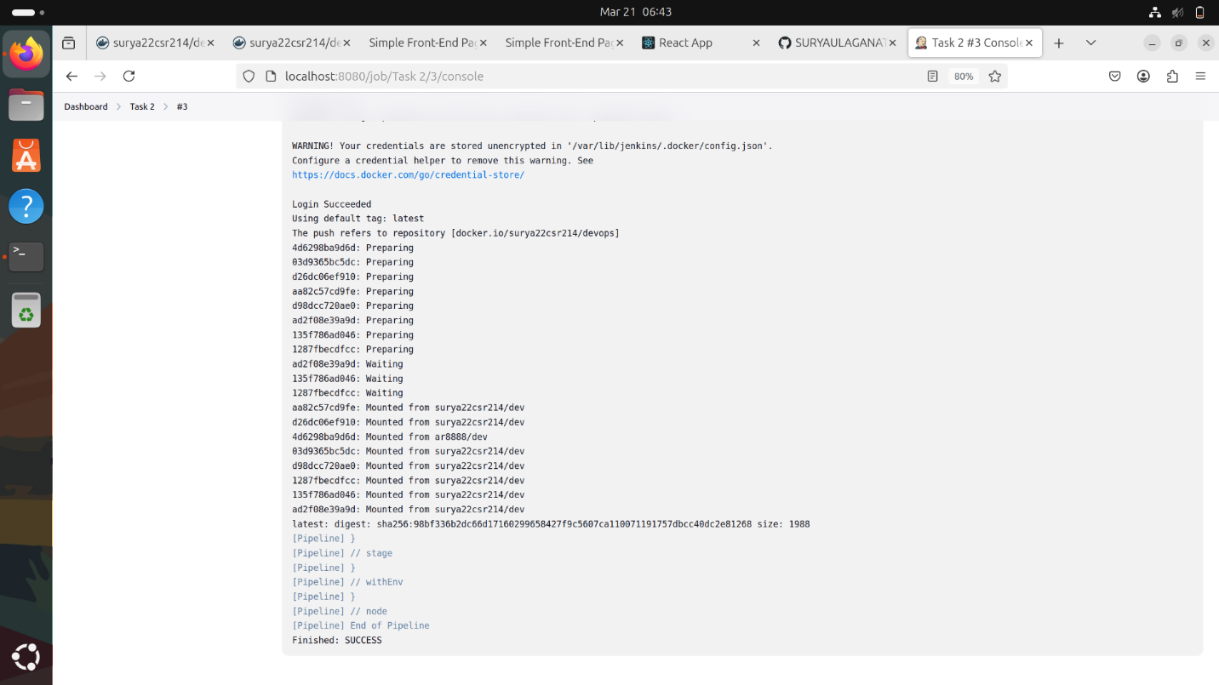

**STEP 7 : AFTER STEP 6 , GO TO THE BROWSER AND SEARCH FOR LOCALHOST:<PORT_NUMBER> AND THE RESPECTIVE APPLICATION WILL BE HOSTED.**

# SCREENSHOT:

# 

**STEP 8 : AFTER STEP 7 , BUT, INSTEAD OF RUNNING THE IMAGE BY MANUALLY , WE CAN ALSO WRITE THE COMMAND FOR RUNNING IN A FILE CALLED DOCKER-COMPOSE.YML.**

# CODE:

version: '3' services:

react-capstone: image: "test1" ports:

- "85:80"

# SCREENSHOT:

**STEP 9 :AFTER STEP 8, SIGN IN NGROK USING GITHUB ID OR USING GMAIL AND INSTALL NGROK BY FOLLOWING BELOW COOMANDS:**

**COMMANDS:**

sudo snap install ngrok

ngrok config add-authtoken $YOUR_AUTHTOKEN

ngrok http 8080

**STEP 10 : AFTER STEP 9, GO TO THE SETTINGS YOU REPOSITORY AND ADD WEBHOOK.**

**STEP 11 : AFTER STEP 10, GO TO JENKINS ,CLICK RECENTLY CREATED ITEM, CLICK CONFIGURE BUTTON AND CLICK TRIGGER AND TICK THE CHECKBOX OF GITHUB HOOK TRIGGER FOR GITSCM POLLING IN JENKINS AND FINALLY CLICK SAVE BUUTON.**

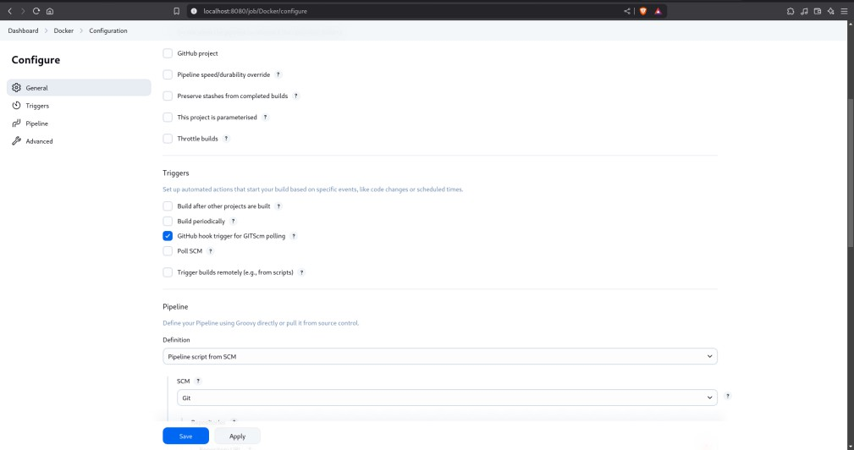**SCREENSHOT:**

**STEP 12 : AFTER STEP 11 , AS YOU CAN EDIT ANYTHING IN YOUR REPOSITORY AND GIVE COMMIT CHANGES.**

**FOR EXAMPLE:**



**AND IT WILL AUTOMATICALLY BUILD IN YOUR JENKINS ITEM.**